1. **Subscribe for “openweathermap” to get the API key for https://openweathermap.org/**

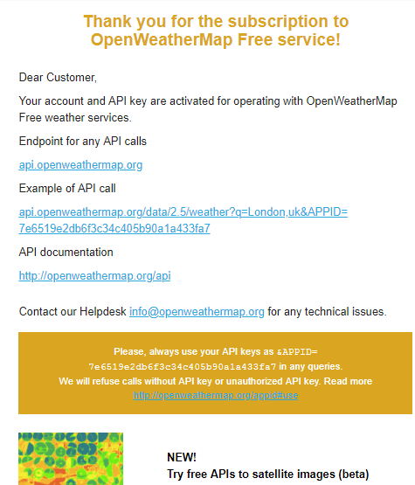

1. **GET current weather data for one location – London**

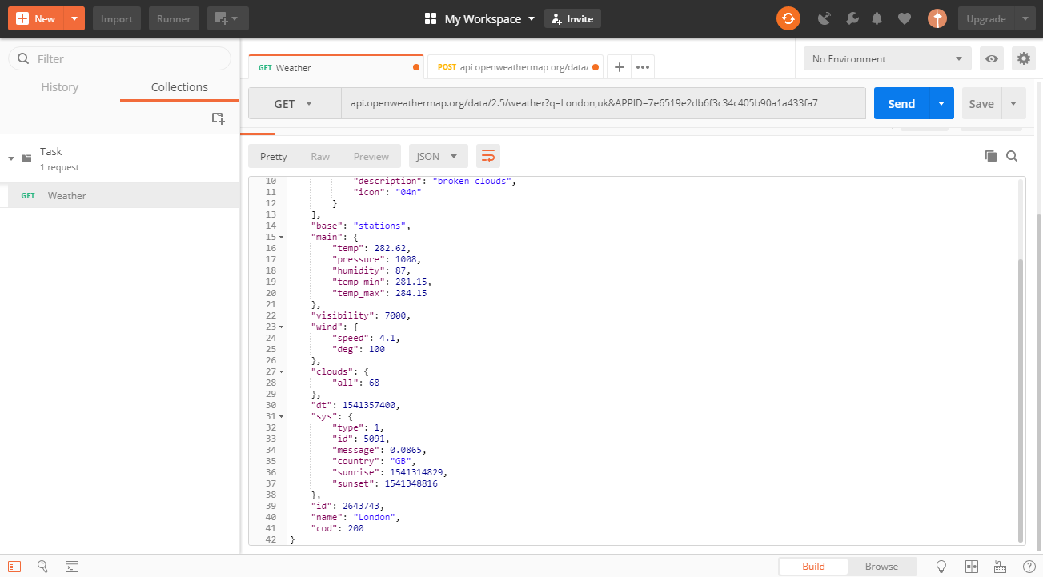

1. **POST /stations – In Kharkiv**

This method is used to register a station in the OpenWeatherMap service. You need to pass a set of parameters: external identifier, station name and its geographical arrangement. In case of successful creation method returns an HTTP code 201.

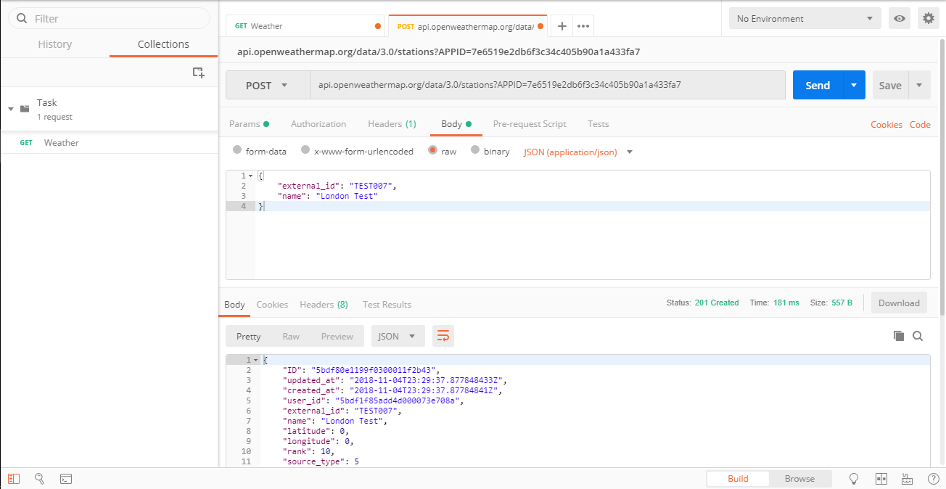

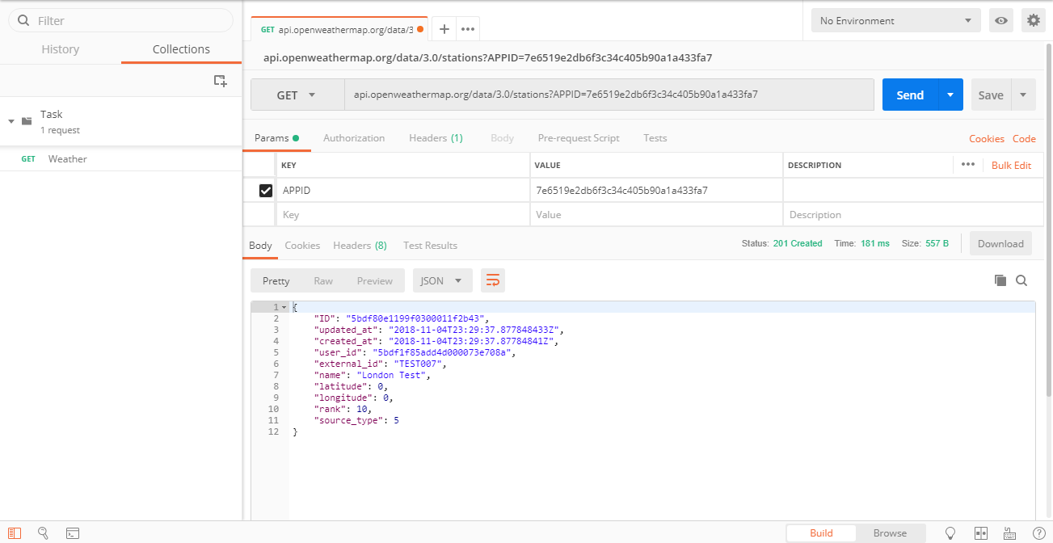

1. **PUT /stations/{:id}**

This method is used to change information about the station. Parameters available for modification: external identifier, name, geographical arrangement, height above sea level. In case of successful change method returns an HTTP code 200.

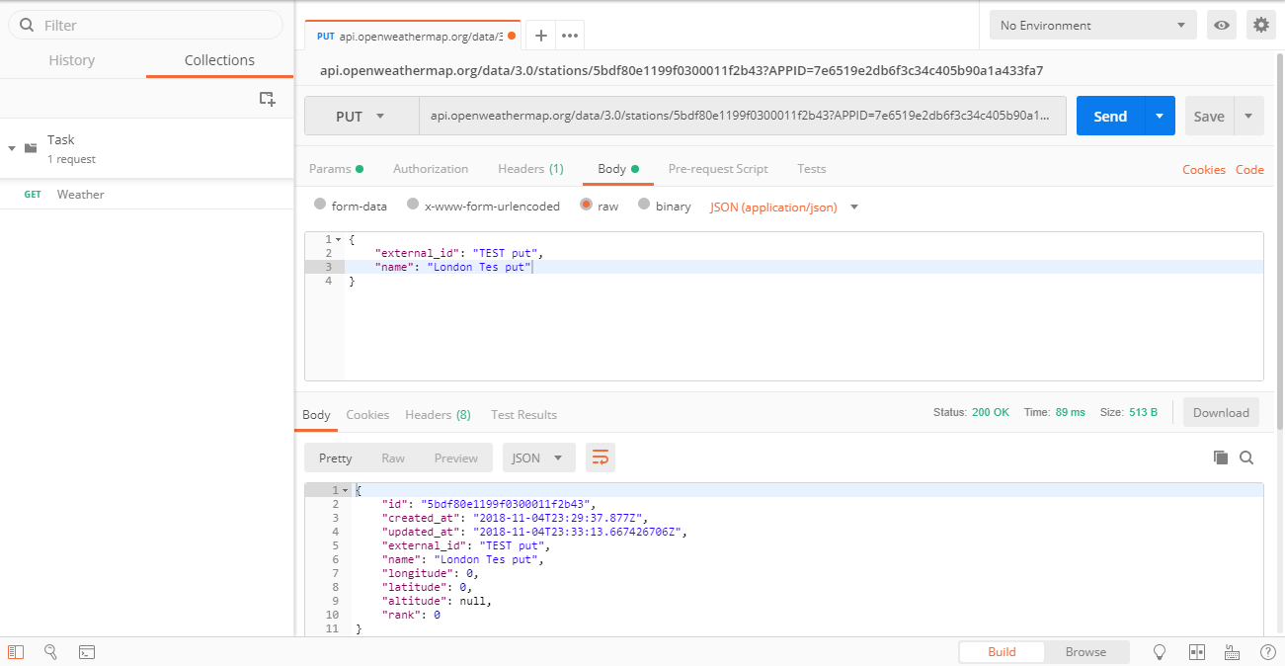

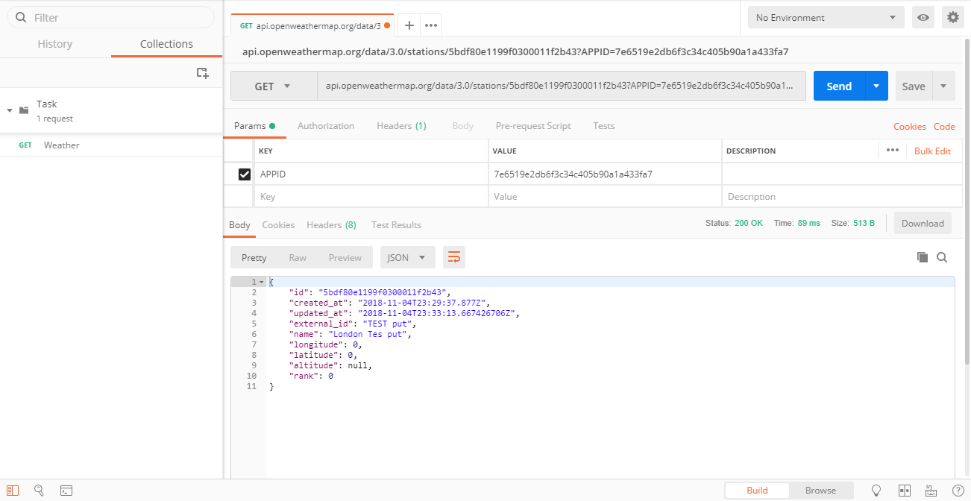

#### ****[DELETE] /stations/{:id}****

This method is used to remove a station from your account. In case of successful removal method returns an HTTP code 204 (Successful answer). Be careful: after this operation all measurements received from the removed station are deleted permanently, so they couldn't be restored.

